Term Project
CIS- 4303
Julio Orellana
12/06/2025

Gym Progress Report
Problem Statement:
We want to know the moderate weight and instances of the subject. The subject is curious as to what his overall mean weight and instance of his weight are and what workouts he mainly achieves. His curiosity is to identify the trends and likelihood of day-to-day workout plan.
Solution:
Run a hierarchy cluster model where we can visualize the clusters and find the hidden patterns of the individual’s progress to dictate what is affecting the overall weight change.
Dataset Description:
The dataset description is six columns of workout data. The columns are the date, weight (in kilograms), Calorie intake, Protein intake (in grams), Workout Duration, and Steps taken throughout the day. This dataset was derived from one individual which is the subject. All the workout data is their day-to-day data input from a time series starting 01/01/2025 to 07/19/2025.
That’s 7 months of workout data, each day of every month has a log and are filled with the daily workout results.
Dataset Link:
- https://www.kaggle.com/datasets/rishabhagarwal997889/gym-progress-tracking-dataset-200-days
Data Preprocessing:
We standardized the dataset to run the hierarchical cluster model. We standardized it in python using sklearn.preprocessing’s scale tool. We conduct this standardization to ensure model performance and prevent slower convergence.
Problem Type:
The problem type is an unsupervised problem. The reason being that there is no set label or data labeling. This leads to the desire to unlock and discover unlabeled groups and patterns that are of interest to the subject and us.
Cross Validation:
Cross Validation was not applicable at this time.
Data mining Technique:
The technique used for the project was Hierarchical Cluster Analysis. An unsupervised technique that allows us to find unlabeled data groups. We utilize this analysis technique due to the fact that there are no labels or data label groups. Our main interest in this project is to identify the most common cluster of variables and how they relate to each other and what impact they have on the target variable weight.
Programming Tools:
For the Programming Tool, we used Python to help us conduct data analysis. Moreover, we used the IDE or more the hosted IDE of google collabs to be able to have a development space to conduct this data analysis.
The libraries that were used were the following:
  - Pandas
  - Scipy
  - Sklearn
  - matplot
Model Evaluation:
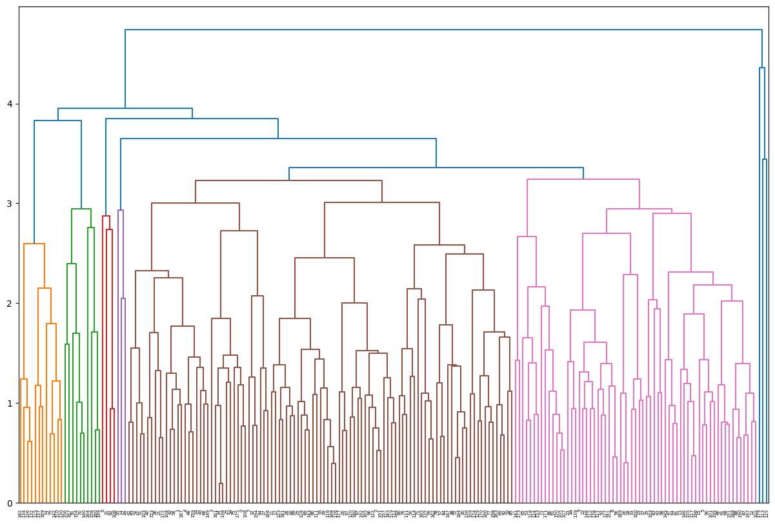
- Full Dendrogram Cluster analysis plot
Looking at the Model’s Dendrogram plot we can see that the model has tall merges around the 3.58-4.0 height and furthermore there are addition separations in the 2.5-3.0 heights.
To avoid Over splitting we will settle on a height of 2.0-2.5 which leads us to cut the trees down to 10 branches
We will follow this evaluation by also judging the silhouette score and deciding if we should cut the tree further or decrease the branches cut. Moreover, we will also use another metric methods such as ward’s method.
The following is the split dendrograms for the cluster analysis:
  - 7 Branches
    - 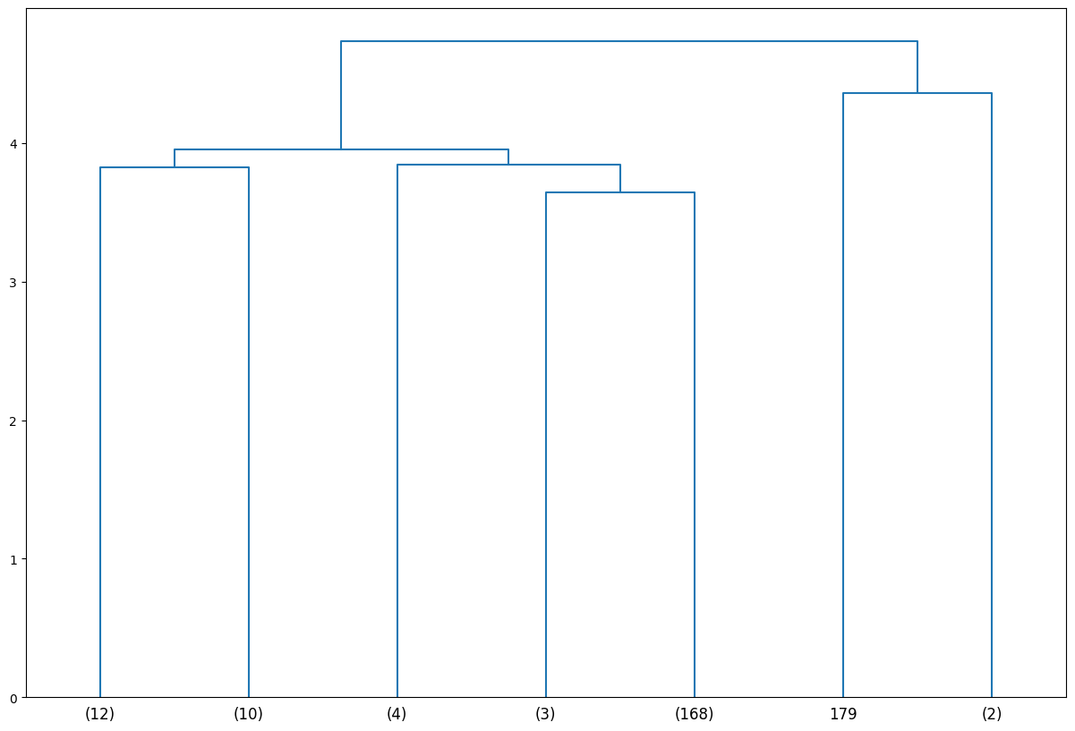
  - 10 Branches
    - 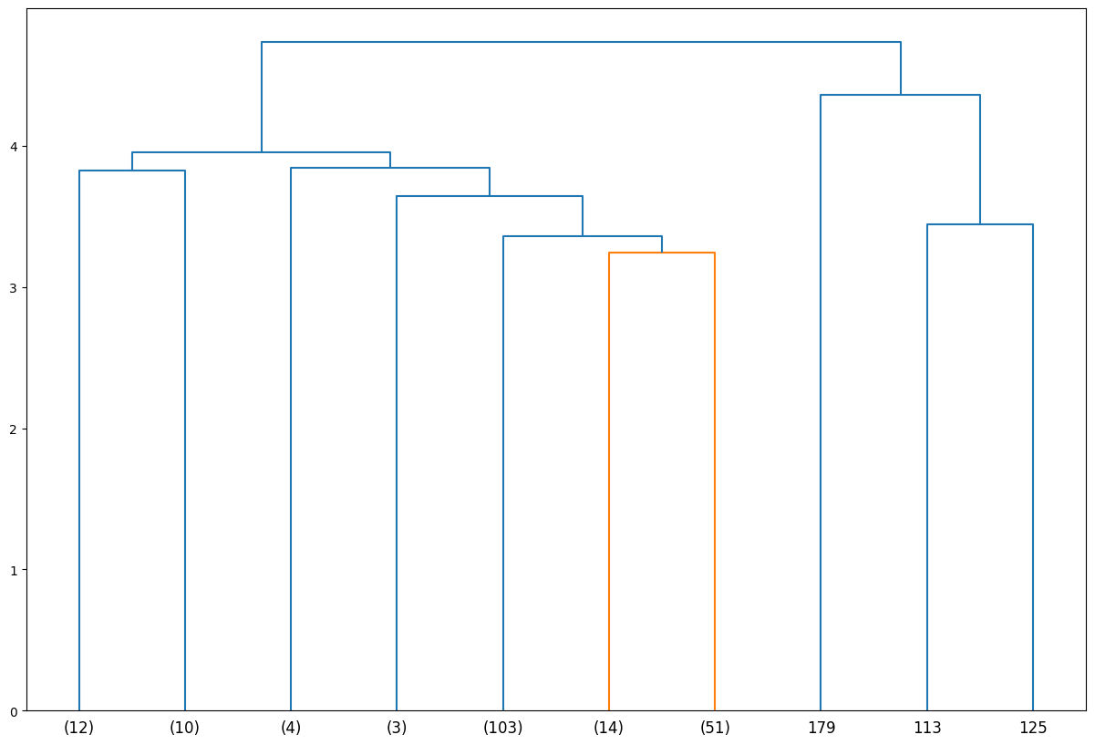
  - 35 Branches
    - 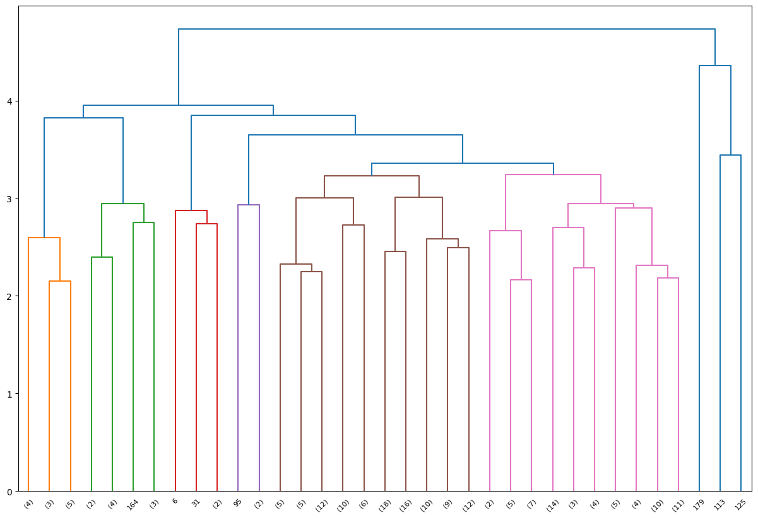
- Model Evaluation Using Ward
  - 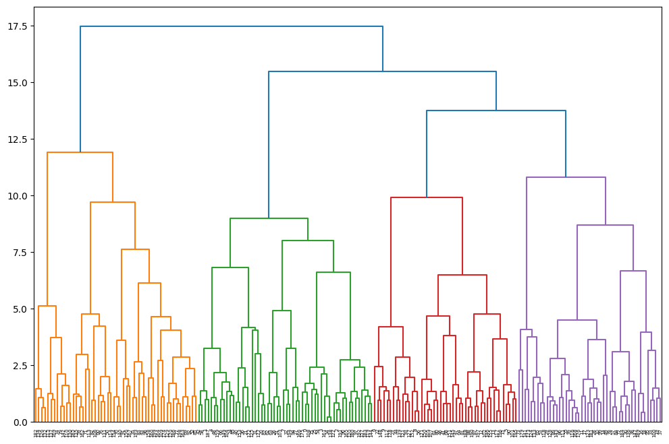
  - 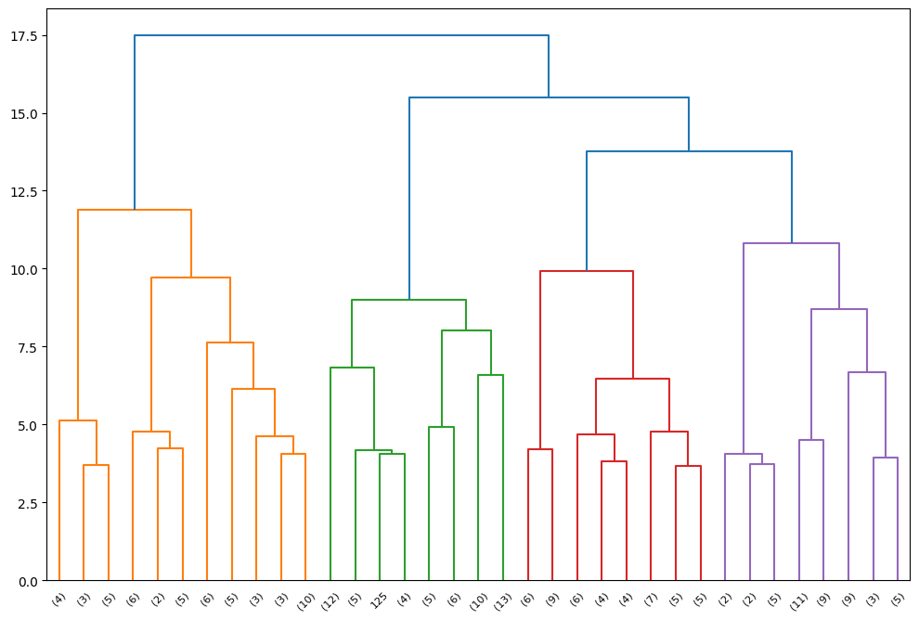
We only will display the 35 branch Cluster as it is the only usable cluster. However, it is important to note that the performance metrics for the Ward cluster analysis is better overall.
    - 35-Branch Silhouette Score: 0.2869
    - 10- Branch Silhouette Score: 0.1861
    - 7-Branch Silhouette Score: .1575

Performance Metrics:
For the performance metrics we utilize the silhouette scoring method to evaluate the Cluster model’s performance. We ran three different Cluster models where we cut the dendrogram’s branches between 7, 10, and 35. We arrived at these three different cluster splits after various trial and error attempts on the model.
- The Silhouette score for the 7 branch Cluster model: .0503
- The Silhouette score for the 10 branch Cluster model: .0874
- The Silhouette score for the 35 branch Cluster model: .2688
As we can see the Silhouette score was very low and so to find a better score, we concluded that there were either too many or too little splits. However, as shown by the Silhouette scores above we can see the answer was that there were too little splits.

Results:
- Below are the resulting tables and means for the Cluster analysis:
  - 7 Branch Cluster analysis:
  - 10 Branch Cluster analysis
  - 35 Branch Cluster analysis
Research Result Review:
When Viewing the Cluster analysis results for the three models we can see that there is a lot of variances and change between the weight variable and the other variable leading us to conclude that there is no direct relation to the weight variable between calorie intake, workout duration, Steps walked, and protein Intake. Moreover, we can see that the mean weight that mostly shows up in all the Cluster analysis is between the 69.25-70.4 kg weight range.
  - In the 7-branch cluster model, we see an instance of 168 times for the weight of 69.89.
  - In the 10-branch analysis, we see an instance of 103 times for the weight of 70.3.
  - In the 35-branch analysis, we see an instance of 18 times for the weight of 69.75.
The pattern that we do find is that the subject does seem to carry their weight around the 69-70.3 range mainly throughout the 7-month time period with over 150+ instance judging off the three models.
In our model evaluation we also see that when we check the model with the ward metric method, there are different silhouette scores that occur. The results of the Ward models do produce different table numbers and Dendrograms as well. Most importantly the silhouette Scores in the Ward linkage Cluster model shows us that it is a preferable Model when compared to the average linkage
The evaluation of the silhouette scores also shows us that the first two models are not usable as the silhouette model has heavy overlap. The last one is the 35-branch Cluster model which results in a silhouette score of .2688. This score is usable score however we see a very weak structure in the Cluster model. The end conclusion is that we could strengthen the model by further branch cutting, however we could also see a result of over splitting occurring in the end.
Challenges and Limitation:
This data is still lacking and has too many outliers as well. There is too much variance and change within the data where we see the model report low weight instances with high calorie intake, low steps, and low workout duration periods. Moreover, there is a very important question that needs to be asked which is whether the subject consists of consistently weighing himself around the same time of the day or after certain activities. Weight can fluctuate and be affected by water retention, perspiration, fasting, sodium intake, and more.
A huge challenge was identifying the issue with the model due to the poor silhouette score in which we tried to identify if the Model had too many or too few clusters. The answer was too few as we arrived at a 35-branch Cluster model. Moreover, this still did not change even when we changed the metric method from average linkage to ward’s.
Suggestions:
Our suggestion would be to ask the subject to try and follow a more consistent workout regimen as his current workout plan has too many overlapping variances that do not allow us to identify any correlation or relation between the other variables and weight. Moreover, we also would like to inform the Subject to weigh themselves every morning at the same time and with consistency. Also, we would like to include other outliers such as water intake and sodium intake. Finally, and most importantly when we do run another Cluster analysis we do suggest the use of Ward’s linkage.

